1. Use case diagram kamus indonesia-korea

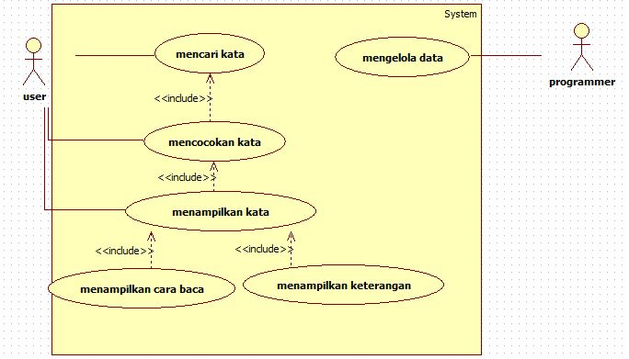

1. Use case diagram kamus indonesia-korea

